Renju lesson on April 18, 2002

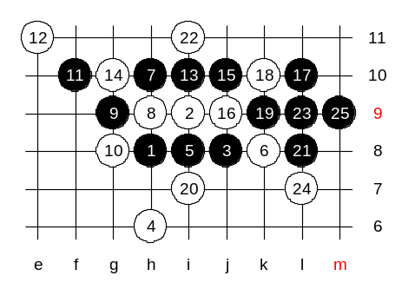
Hello everyone! Welcome to Online Renju Class. Is there anything important we have not discussed about 4-i7? Can we change the 4th move today? Maybe, we try 4-h6 first, just to point out one wrong diagram of click of stones book. The way Click of Stones book shows black win after 4-h6 is wrong and black fails.
Where are the 5th moves? Any idea? ;) So far no perfect answer yet. Perfect answer is when you offer two 5th moves correctly. :) Yes, i8 and i10 are the correct ones. This 4th move looks silly but in fact causes lots of headache. H6 stone stands very well in fact and co-operates with i9 in defense plan. Ok, we check 5-i8 first. Let's see how Click of Stones tells us the win. Black wins by the 25th move. Everyone agrees?

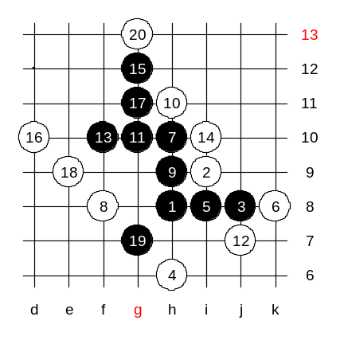
Well, it is win all right. But the problem is that white helped a bit. Yes, white can change earlier. And the book missed one important change.
Move 8-f8 a strong defense!
Black can not continue with positional style and is forced to attack directly. Move 16 - a powerful weapon! The overline structure causes the failure of black attack. By the 20th move black is almost dead.

For my book, I had to prove black win. I finally did. But I had to go long way back first.
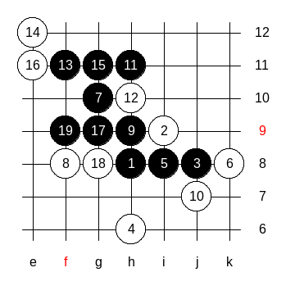
I wrote the win on 3 diagrams, I will publish them all here now. 7-g10 is the start.
The first block gave easy win.

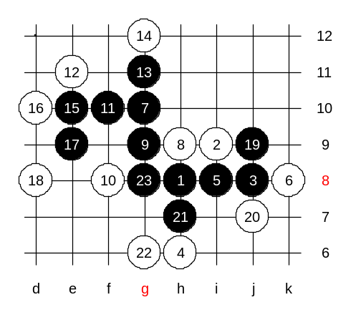
This 8th move is stronger, but great 9th move gives win.

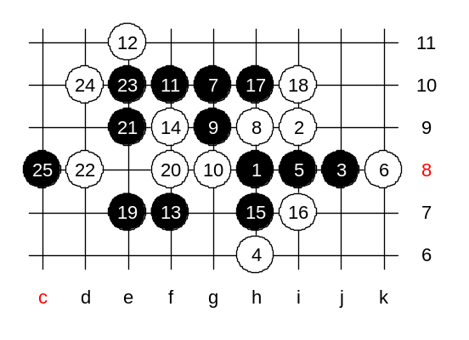
The last diagram, the 10-g8. I just wrote 13 moves, and checked the following, without having need to write down the endings. Black wins everywhere. As a tradition, we will play one example path to show it. Students, you may choose the defense. Wow, f9 is interesting. Lets see now how black wins.
Who can tell the win in 3 moves (4x3)?

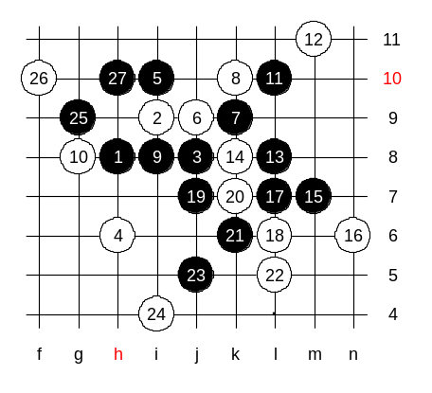
We are done with this 5th move finally.
Another 5th move has more feeling of positional style. The variant in my book seemed like a strongest white resistance, so I wrote it down.

We are now finished with this 4th move. It was a bit harder than most of you expected, wasn't it? Oh one more thing, there is a comment in the book: In case of 4-j6, black can play exactly as in case of 4-g6. The board edge does not influence any of those diagrams.
We can now finish the lesson, thank you for participating, we meet again next week! :)

